Virtualization

Virtualization is the process of running a virtual instance of a computer system in a real computer system. It allows us to simulate the existence of hardware by using software. The applications running on the virtual machine think they are interacting directly with the hardware, but actually, they are separated by a layer of abstraction that is the base OS running on the system.

Virtualization allows the running of multiple instances of computer systems on a single hardware set. There are many applications of virtualization, like being able to run applications meant for different operating systems without having to switch OS or reboot, or allowing multiple users to run a machine on the same computer system, etc.

Basics of Virtualization

Each virtual instance of a computer system is called a virtual machine. Each virtual machine has its own set of simulated hardware. The OS in each virtual machine has no idea that it is running on a virtual machine rather than a real machine.

Some important terms related to virtualization are:

* **Host:** The actual physical computer system on which the virtual machine is running.
* **Bare metal:** Another name for the host.
* **Guest:** It refers to the virtual machine running on the host.
* **Guest Operating System:** The OS that runs on the virtual machine.
* **Hypervisor:** It is the software that creates and runs virtual machines.

Hypervisors

Hypervisors are software that create and run virtual machines. They provide the guest OS with a virtual operating platform and manage the execution of the guest operating systems.

**Types of hypervisors:**

* **Native or Bare Metal hypervisor:** These hypervisors run directly on the host's hardware to control the hardware and to manage guest operating systems. For this reason, they are sometimes called bare-metal hypervisors. The first hypervisors, which IBM developed in the 1960s, were native hypervisors. These included the test software SIMMON and the CP/CMS operating system (the predecessor of IBM's z/VM). Modern equivalents include Nutanix AHV, AntsleOs, Xen, XCP-ng, Oracle VM Server for SPARC, Oracle VM Server for x86, Microsoft Hyper-V, Xbox One system software, and VMware ESXi (formerly ESX).
* **Hosted hypervisors:** These hypervisors run on a conventional operating system (OS) just as other computer programs do. A guest operating system runs as a process on the host. Type-2 hypervisors abstract guest operating systems from the host operating system. VMware Workstation, VMware Player, VirtualBox, Parallels Desktop for Mac and QEMU are examples of type-2 hypervisors.

Creating own virtual machine

To create a virtual machine, we need to follow the following steps.

**Step 1: Download a Virtualization software**

There are many options. I will be using Virtual Box.

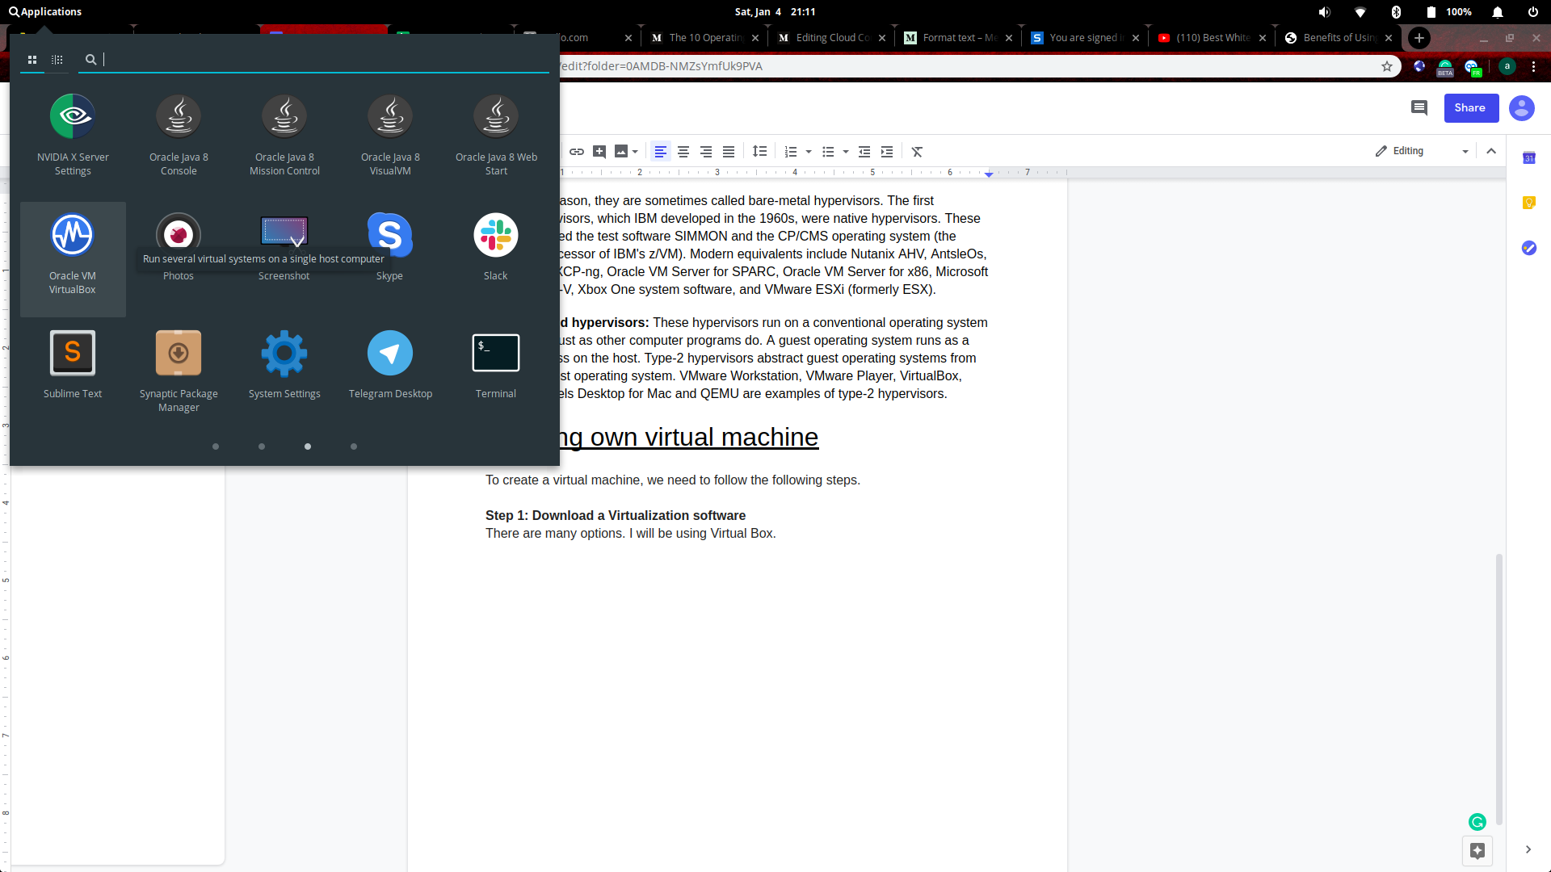

**Step 2: Create a new virtual machine**

On opening the virtual box, this is the first screen that will appear.

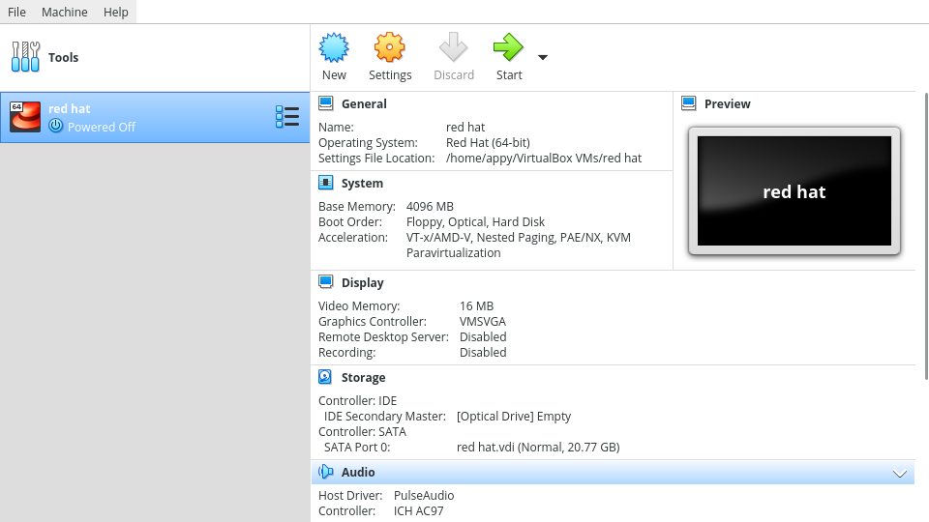

Click on the new button.

**Step 3:**

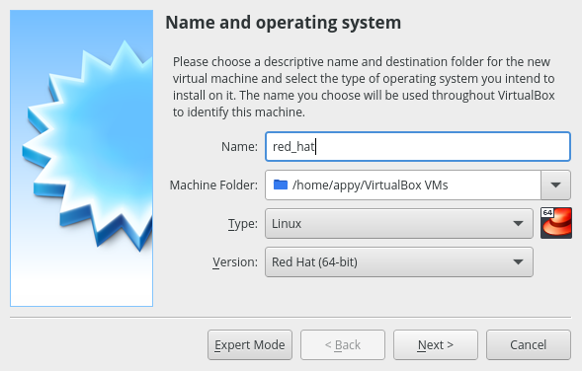

Here you can specify the name of the OS and type. I am using red hat 64-bit.

**Step 4:**

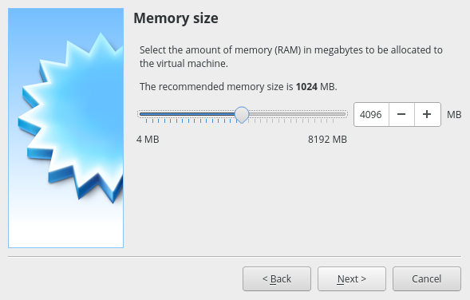

This is for RAM size. Normally Linux systems can run on low specs as well, but 4GB is recommended.

**Step 5:**

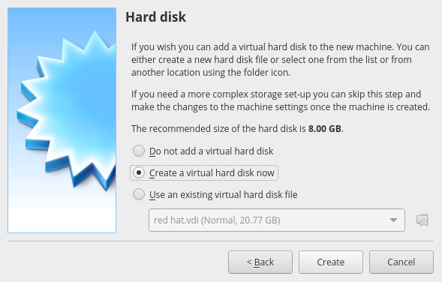

Virtual machines use virtual hard disks that are just sets of files on the hard disk. The virtual hard disks allow us to take our virtual machines anywhere with us.

So, here you could choose to create a virtual hard disk later, pick an existing one or create a new one.

**Step 6:**

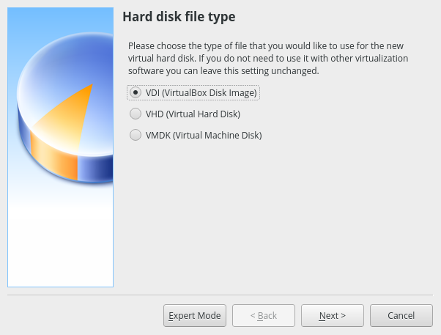

Different types of hard disk file types exist, but they have little differences. VDI is a virtual box’s own format and supports almost all operations on virtual hard disks, but is only supported by Virtual Box. VMDK is similar to VDI but it is VMWare’s format. It is good if you want a more portable virtual machine because VMDK is supported by some top virtualization software. VHD is Microsoft’s virtual disk format.

I will be continuing with VDI.

**Step 7:**

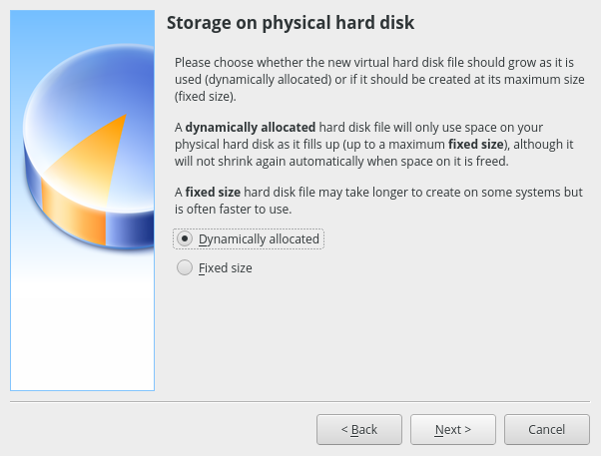

Here we decide whether we want the system to preallocate the storage space used by the VM or let it grow as needed.

Fixed Size is good when you want the VM to have storage at any cost.

But dynamic allocation is better suited for when you have a general idea of what amount of data you might need in the future, but currently, it is not needed.

I am going to continue with Dynamically Allocated.

**Step 8:**

Here we define the maximum amount of storage allowed to the virtual machine. The virtual machine cannot occupy more space than this.

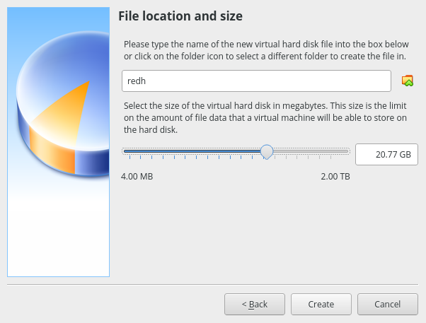

**Step 9:**

After clicking ‘Create’, you will be lead back to the home screen. There, select the virtual machine and press start.

**Step 10:**

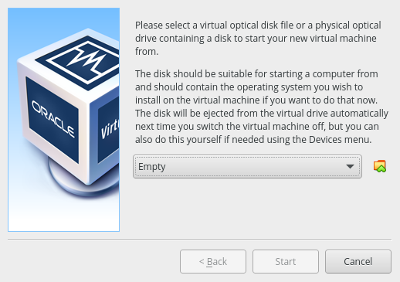

A screen like this will appear. Click the folder icon to browse to the needed ISO file. You need to download the ISO file for your preferred Operating System.

**Step 11:**

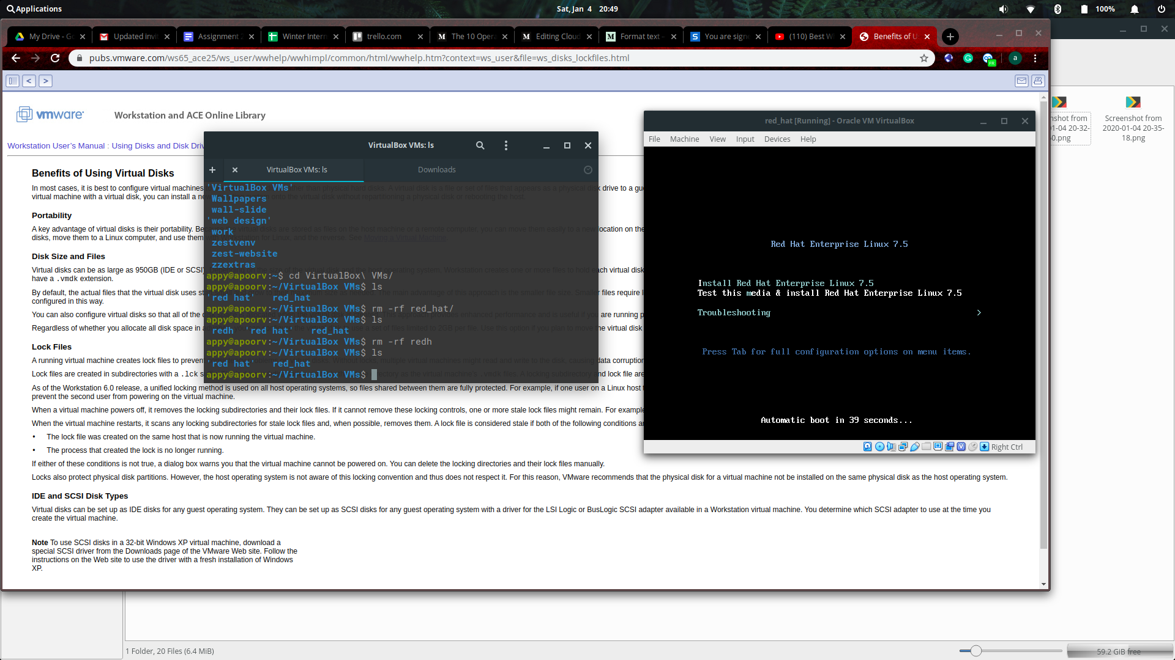

Moving forward, you’ll see this screen. Continue with the installation software.

**Step 12:**

Follow the installation wizard and finish the installation.

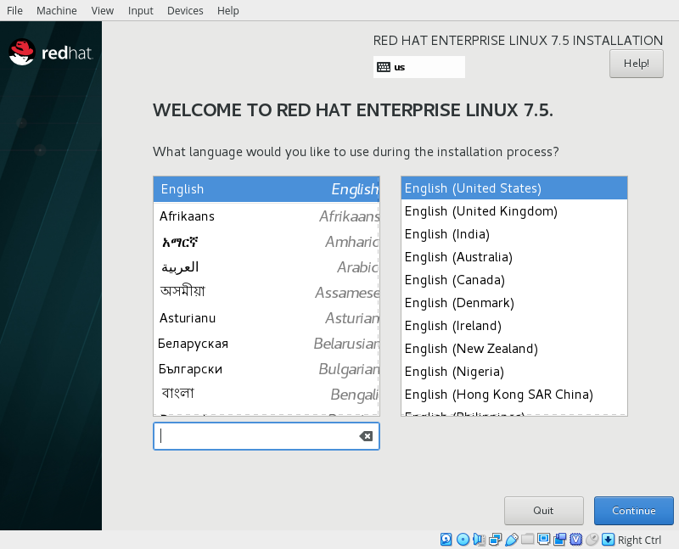

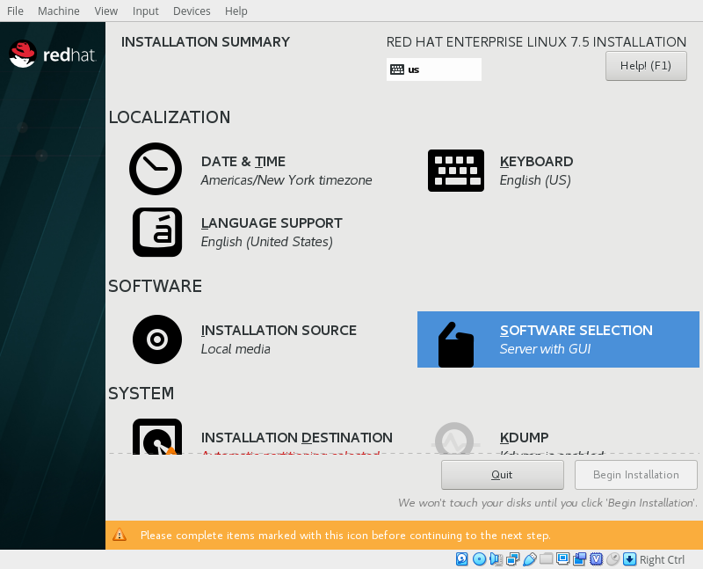

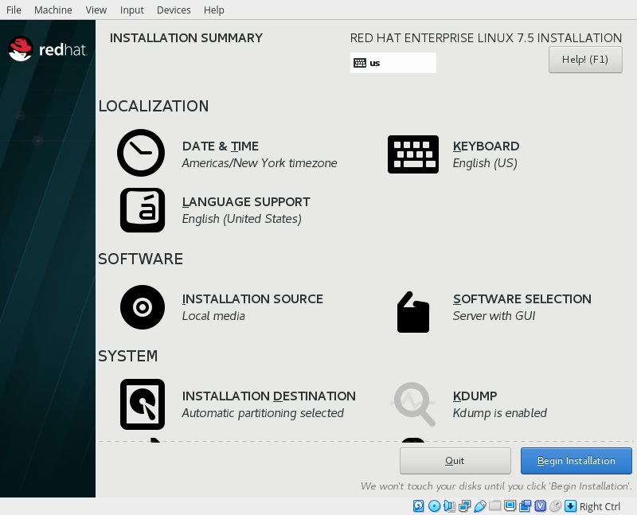

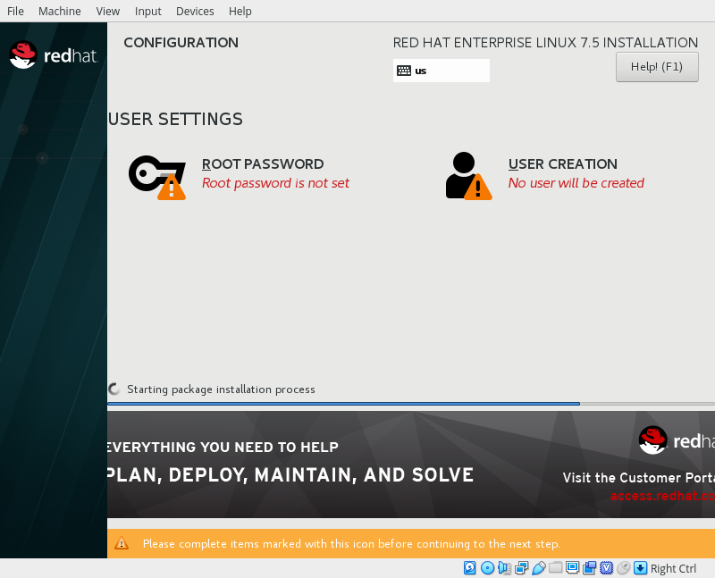

**Step 13: Done!**

